Stefon Miller

CS1550

Project 3 Writeup

In order to conduct my experiments on the optimal and least recently used algorithms, I ran each algorithm on the provided 1.trace file with various page sizes, frame numbers, and memory splits. From my experiments, I concluded that increasing the number of frames can decrease the number of page faults, and as the number of frames increases the memory split becomes less impactful on the number of page faults. This is demonstrated in the below graphs:

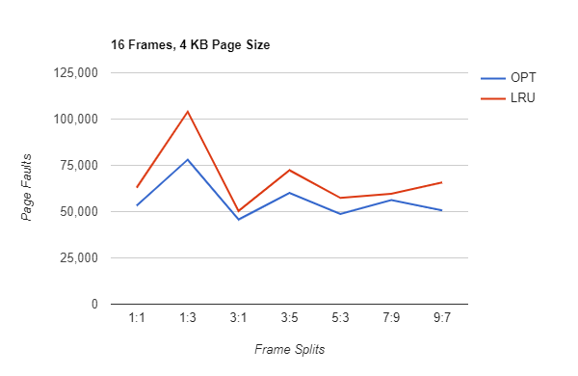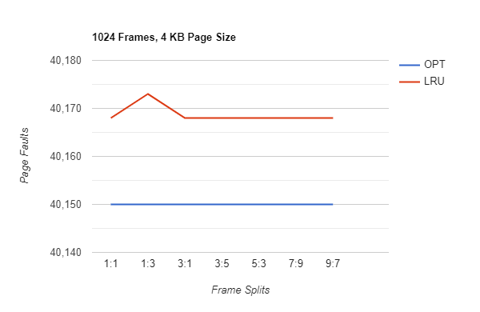

From these graphs, it can be determined with a high frame number, LRU performs almost optimally with any memory split. However, with a small frame number, both algorithms fluctuate drastically with the memory splits. I also determined that increasing the page size reduces the number of page faults. This is demonstrated in the below graphs:

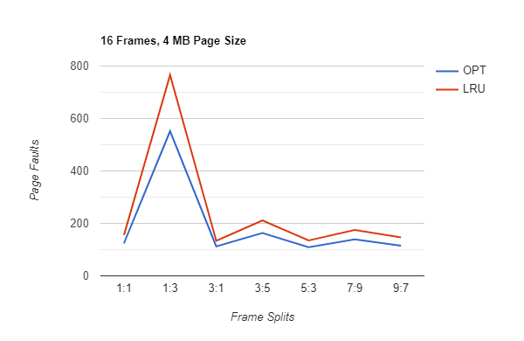

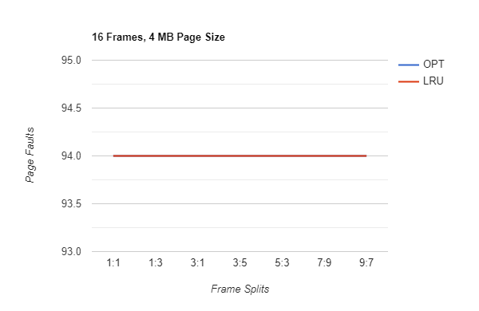

From these graphs, it can be concluded that moving from a 4 KB to a 4 MB page size reduced the number of faults from tens of thousands to less than one thousand. Even with a higher frame number, the graph with smaller page size had orders of magnitudes more page faults than the one with a higher page size.